NH Fire Academy and Emergency Medical Services
Human Dignity Statement
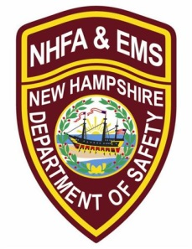
The uniqueness of all individuals attending training is recognized as well as their diversity, which can be a resource that enriches the learning environment through sharing of differing perspectives. An equal learning opportunity is provided to all course participants. This is supported by:
- Ensuring equal opportunity to all students, staff, and instructors;

- Prohibiting all discrimination and harassment;

- Supporting affirmative employment policies and practices on behalf of minorities, women, and people with disabilities;

- Encouraging students, staff, and instructors to communicate and behave in a manner which is sensitive to, and acknowledges the viewpoints of others;

- Regarding diversity as a resource that enriches the learning environment through the sharing of differing perspectives, experiences, and ideas;

- Removing barriers to teamwork through collaboration, problem solving, and the constructive resolution of conflicts; and

- Continuing to identify and eliminate barriers to training, employment, and advancement of minorities, women, and people with disabilities.

Participants, instructors, and staff are expected to treat each other with respect at all times. Inappropriate behavior will not be tolerated and may result in removal from a NHFA and EMS course.

